
Health & Safety Policy 2025-2026

Sunningdale School
Doxford Park Way
Sunderland
SR3 2PP

Sunningdale School is the working environment for many groups of individuals and plays host to many others. It is important, therefore, that a safe environment is established in which children and adults can work together with confidence. It is the responsibility of the Senior Leadership Team and Board of Governors to ensure this is the case.

In order to promote this we must all take responsibility for being vigilant and be aware of possible risks. Children and adults should be encouraged to look out for themselves and one another and share any concerns they may have swiftly and appropriately.

We must also, however, be aware of the need to keep a balance between security and safety and the maintenance of a comfortable, welcoming learning environment. This policy aims to address and provide guidance on this balance, identifying individual and group responsibilities.

Aims
- To provide a safe, secure and healthy working environment for staff and children by so as reasonably practicable.
- Ensuring assessments are undertaken and control measures are adequate to prevent realisation of risks
- Allocating adequate resources for the management of health and safety risks.
- Identifying the training needs of employees and ensuring relevant training is provided
- Investigating incidents and identifying appropriate remedial action
- Ensuring health and safety audit reports and action plans are implemented within the timescales required.

Informing People of this Policy
There is a copy of the policy in the ‘Policies’ folder on the school’s internal staff server.

Staff are informed when the policy is updated.

The policy is ratified by Governors through the Policy Review Committee in line with the Policy Review Schedule.

All members of staff are issued with the policy and required to sign the register to acknowledge that they have read and understood the policy.

Visitors have their attention drawn to basic health and safety information on entry to the school and those likely to visit school on a regular basis are requested to read the policy.

New members of staff receive health and safety information as part of the induction policy.

It is the responsibility of teachers to ensure that significant health and safety risks are identified during lesson planning and preparation to ensure adequate controls are implemented where necessary and that lessons are supervised accordingly.

Responsibilities of the Governing Body
- Ensure the high profile of health and safety in relation to financial planning, personnel decisions and in-service training.
- Ensure that policies relating to health and safety are in place and updated regularly
- Enable a member of the governing body (Karl Sollis) to have a key monitoring role in relation to health and safety including a termly walk around the school building with the Site Supervisor, School Business Manager and the Headteacher.
- Ensure that safety standards for purchased goods and equipment are met and that items offered for sale by the school are safe.

Responsibilities of the Headteacher
- To ensure the Council, Directorate and school’s Health and Safety policies are fully implemented and for day to day management of health and safety in Sunningdale School
- To undertake risk assessments as and when required and review regularly
- To investigate accidents and incidents and implement remedial action to prevent reoccurrence
- To ensure policies and employees are updated as to new legislation and guidance
- To provide employees with adequate training instruction information and supervision
- To ensure that temporary/supply staff are informed of basic health and safety policies and procedures
- To meet with health and safety representative of the Board of Governors to discuss health and safety issues
- To report on any audits/inspections to the GB and implement recommendations
- To ensure that procedures are in place to ensure the safety of contractors and hirers.

Responsibilities of Individual Teachers
The following list is a guide to the particular responsibilities that individuals have
  - Know the safety measures and arrangements to be adopted in their own working areas and ensure that they are applied
  - Know and apply the procedures in respect of emergencies
  - Co-operate with Headteacher, Site staff, School Business Manager in promoting health and safety measures
  - Follow health and safety instructions and use appropriate safety equipment and protective clothing
  - Maintain safely tools and equipment
  - Report any accidents and incidents (including violence at work) incidents and ‘near misses’
  - Make parents/ volunteers aware of safety procedures in the classroom/ work area
  - Ensure that relevant risk assessments are completed and followed
  - To not make physical alterations to the physical fabric of the school building, including attaching shelves and equipment to walls, without the express permission of the Headteacher.

Responsibilities of Post-Holders
Mr P Dunn Chair of Board of Governors
Mr K Sollis Board of Governors (Health and Safety)
Mr J. Waller Headteacher
Mrs C. Beattie Deputy Headtecher
Mr J. Moffatt Deputy Headteacher
Mrs S Ridley Assistant Headteacher
Mrs N. Headen Business Manager (overseeing premises)
Mr. E. Cuthbertson Site supervisor
Mr. D. Straughan Assistant Site Supervisor.

Those responsible for others should ensure that:

- Members of their team are complying with health and safety regulations
- Draw the attention of the Headteacher to any breach of procedure amongst their team which cannot be dealt with
- Supply teachers, temporary staff and new members of permanent staff are made familiar with health and safety procedures
- The Head teacher or Premises Manager are informed of any premises related accidents or near misses.
- Ensure accidents and incidents are reported using the IR1 reporting procedure.
- Report any defects in premises or equipment the Headteacher and or Premise Manager and to notify Headteacher of any other H&S related issues
- They keep an overview of the parts of the premises for which they are responsible
- All donated equipment is safe for use, if necessary seeking specialist advice
- They implement existing policies and procedures and follow advice and instructions

Responsibilities of Visitors
Regular visitors and other users of the school will be required to observe the safety rules of the school. The headteacher will ensure that visitors are informed of health and safety matters which may affect them during their visit.

Parents helping out in school will be made aware of the health and safety arrangements by the teacher who they are working with.

Groups of people who regularly hire the premises will be made aware of safety arrangements through our hiring information and H&S responsibilities e.g. first aid and fire warden provision will be detailed in the lettings agreement in discussion with the School Business Manager, Headteacher and/ or Governing Board.

The Board of Governors and Headteacher have agreed that the following procedures/ codes of practice shall be followed within the school:

Accident reporting
All accidents should be recorded on an internal accident form and the details forwarded to the Headteacher for action. In the absence of the Headteacher the Deputy Headteachers or Assistant Headteacher must be informed.

Premise related accidents should be reported to the Site Supervisor and school Business Manager as well as the Headteacher.

Where necessary parents/guardians or other persons should be notified of the accident and action taken to ensure the location of the accident is still safe to use. Parents should be informed by the relevant section of the accident form and where necessary via the home-school diary or telephone directly.

COSHH (Control of Substances Hazardous to Health)
Our school is aware of the requirement eliminate the use of any hazardous substance or where this is not possible use alternative less hazardous substances. All staff procuring hazardous substances must ensure a Material Safety Data Sheet is obtained from the manufacturer and a COSHH assessment undertaken before the substance is used.

Working at Height
A generic Work at Height risk assessment has been undertaken. Individual work at height activities will be risk assessed before work commences.

Risk assessments
Risk assessments must be completed whenever there is the possibility that a hazard or danger might be encountered as part of a school activity. Risk assessments and HSRA2 forms are kept in the administration file in the school office or on the office server. These are reviewed as required.

Risk Assessments for external visits are stored on the main school server and attached to relevant EVOLVE external visit forms within the Evolve platform.

Staff should inform the Senior Leadership Team of any H&S issues or concerns they become aware of.

Educational visits
In addition to the content of this policy reference must be made to the school’s External Visits Policy.

Work experience
Work experience students are co-ordinated by the Administrative Team with support from the Senior Leadership Team. The Administrative Team is responsible for ensuring their induction of students whilst on site. Induction includes explanation of basic and important Health and Safety Information. Where appropriate they will be assigned a classroom based mentor.

Contractors and visitors
The Board of Governors and Headteacher will ensure that the Corporate Control of Construction/Maintenance Code of Practice is adhered to at all times. This will be delegated to the School Business Manager and Site Supervisor, as appropriate.

Contractors are made aware of the location of asbestos and asked to sign to acknowledge that they have received this information. All contractor and visitors are provided with relevant H&S and fire evacuation information. All contractors and visitors entering the premises are required to sign in and wear a visitors’ badge.

Display Screen Equipment
All work stations will be subject to a DSE assessment. This will be organised by the Office Manager with support from relevant IT professional support (Connected IT).

Asbestos
Sunningdale school sites do not have any asbestos.

Fire
A Fire Risk Assessment is undertaken and reviewed regularly by the Responsible Person with support from relevant professionals from Together for Children, the Site Supervisor and Administrative Team.

Responsibilities during fire drill and implementing the fire evacuation procedure:

Headteacher  Deputy Head Teacher | Supervision of evacuation  Evaluation of procedures  Training and guidance
Business Manager  Administrative Team | Calling the fire brigade/meeting the fire brigade at main gate
Teachers  HLTAs  Teaching Assistants | Roll call
Administrative Team | Collect registers & signing in books  Checking visitors
Fire Wardens | To check where possible that the building is empty, doors closed, lights and major electrical equipment switched off (see below).

Fire Wardens

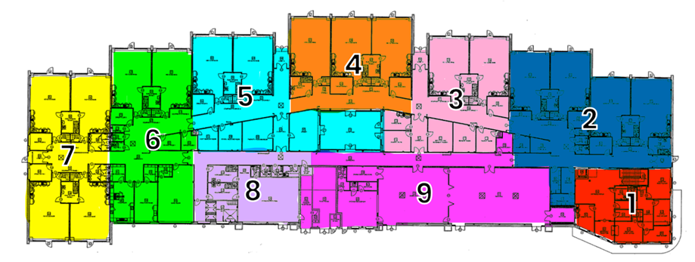

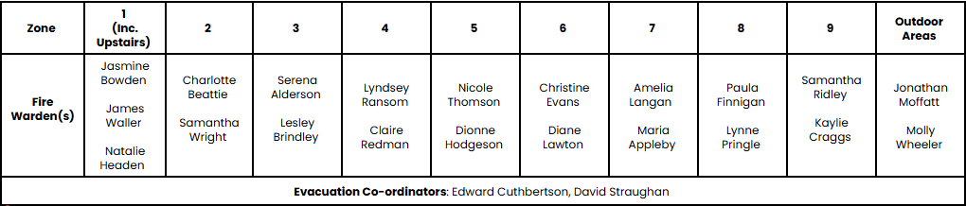

Fire Wardens are assigned to designated areas across the school. Due to the working patterns of senior staff and In order to ensure that areas are covered at all times, teams of multiple wardens are assigned to each area.

In the event of an evacuation, Fire Wardens will visually check that the building is empty, emptying, doors are closed and lights (and major electrical equipment) are turned off as they exit the building.

It is also made clear that every member of staff has a responsibility to support the evacuation. Evacuating pupils remains the key responsibility of all staff. Due to high staff: pupil ratios (1:3) no child should be unaccounted for when exiting.

An evacuation plan is Current (November 2025)

Trained Fire Wardens are:
James Waller
Charlotte Beattie
Jonathan Moffatt
Natalie Headen
Edward Cuthbertson
David Straughan
Maria Appleby
Samantha Wright
Jasmine Bowden
Serena Alderson
Lyndsey Ransom
Aimee Langan
Brogan Wallace
Kaylie Craggs
Tara Porter
Claire Redman
Lesley Brindley
Dione Hodgeson
Paula Finnigan
Lynne Pringle
Christine Evans
Nicole Thomson
Diane Lawton

All staff are reminded termly of the fire exit procedure and more frequently if any changes are implemented.

Early Years Centre:

There is a specific fire evacuation plan for the Early Years Centre (November 2025)

Wardens are assigned to specific zones of the building:
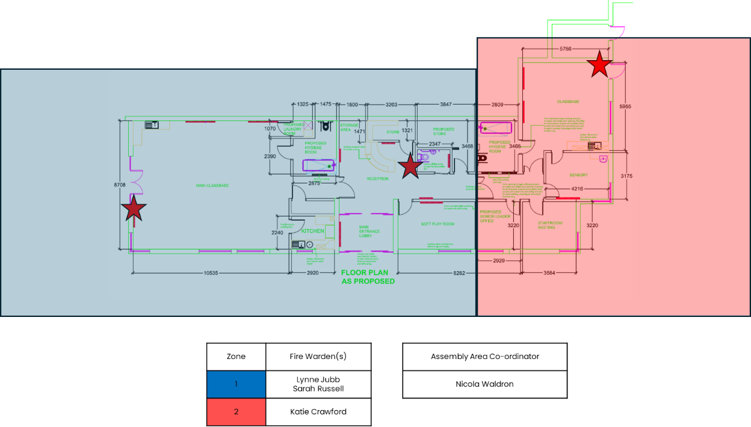
Trained Fire Wardens at the Early Years Centre are:

Nicola Waldron
Katie Crawford
Sarah Russell
Lynne Jubb

Occupation Density Figures
Sports hall | 220
Dining hall | 133

Reporting Incidents
All accidents should be recorded on an internal accident form and the details forwarded to the Headteacher for action. For more serious incidents staff should use an incident form (IR1) to report all incidents, including violence at work incidents (physical assault and or verbal intimidation) and report to the Headteacher so that action can be taken to prevent a re-occurrence.

First Aid
Staff undergo periodic training in:
First Aid at Work
Emergency First Aid
Paediatric First Aid

The following people currently hold a first aid qualification:

Paediatric First Aid | Emergency First Aid at Work | First Aid at Work
Abigial Quinn  Nicola Waldron (Ryhope)  Karen Innes  Amy Marshall  Jasmine Bowden  Brogan Wallace  Carole Dunn  Christine Evans  Claire Redman  Danielle Gales (Ryhope)  Jodie Burlison (Ryhope)  Justine Conlin  Kathryn Tierney  Kaylie Craggs  Sarah Russell (Ryhope)  Siobhan Heslop | Natalie Headen  Serena Alderson  Charlotte Gritton | Serena Alderson

First Aid Equipment
First aid boxes are kept in the:
- Reception
- Sports Hall Store,
- Technology/ Cookery Room,
- Hydrotherapy Area,
- SENhub training centre,
- School Mini Buses.
- School Shop
- School Nurse Office
- Sound room
- Bat Bathroom

To be reviewed termly based on use of the building.

They contain only approved equipment, together with guidance on the treatment of injured people. They also contain latex gloves, which must be used for first aid treatment, particularly if blood is present. This is to eliminate the risk of HIV virus infection.

For the supervising of an out-of-school visit there is a first aid satchel available – staff must ensure that this is taken on a trip and specific medical conditions taken into account. Paediatric first aid will be provided on all EYFS external visits. A member of class staff will have first aid training when on any class external visits.

The First Aid at Work trained staff with support from the Administrative team are responsible for monitoring and replenishing first aid boxes.

Defibrillator Location:
Administrative Sink Area (Outside Headteacher’s Office)
Cupboard in school shop

Near misses reporting
Near misses should be reported to the Headteacher (or relevant Senior Leader in their absence) so that remedial action can be taken to prevent an accident occurring.

Any near misses are then recorded electronically via an internal near miss form (previously near miss book).

Smoking
To help ensure that we offer pupils, staff and visitors a safe, secure and healthy environment our school has adopted a no smoking policy, which covers the school, entrances, car parks, playgrounds and playing fields.

New and Expectant Mothers
Where staff become aware that they are pregnant they should inform the Headteacher in writing so that if necessary additional controls can be put in place. Appropriate rest and nursing facilities will be made available for expectant and nursing mothers and flexible time management should allow nursing to continue according to need.

Monitoring arrangements
The Governing Board may call for annual reports on:

  - Accidents/ incidents
  - Results of internal or external health and safety inspections
  - Complaints
  - Summary of reports or information from Health and Safety Link Governors

Policy review
This policy will be reviewed and amended at least annually or sooner of significant changes occur.

Role | Name | Signature | Ratification Date
Policy Author
(if not Headteacher)
Headteacher | J. Waller |  | Reviewed November 2025
Chair of Governors | P Dunn |  | September 2024

